2017 Stallions Standing at Bedonna’s Stallion Station
Snyder, OK. 580-471-4040 www.bedonna.com

Stallions listed Alphabetically, and then additional stallions, and Junior stallions listed near bottom of list.
NOTE- We accept ALL BREEDS of Mares and Large PONY mares to our Stallions… and we often offer Discounts for PONY mares or un-registered mares. Discounts offered for Multiple Mares (groups of friends/family ok, and mix and match to different stallions is ok), Military Discounts.
Photo of Stallion | Name of Stallion | Color, Color Tests, etc. | 2017 Stud Fee | Pedigree, or other info
Note- All fees come with a Live Foal Guarantee, and some come with a COLORED Foal Guarantee= LCFG)
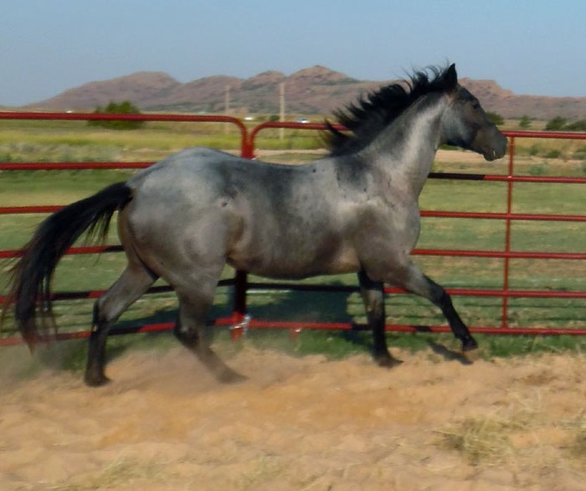 | Blue Perks  AQHA | 2013 Blue Roan  16.0+ EEaaRNrn  Homozygous Black.  Guaranteed Color. | $1100  LCFG | He is 12.5% Easy Jet  18.75% Dash For Cash  15.625% Rocket Wrangler  25% Dash For Perks
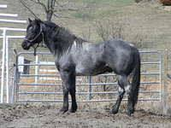 | Blue Valentine King  AQHA | 2004 Blue Roan  EEaaRNRN  Homoz. Black & Roan.  Guaranteed Color | $900  LCFG | 25% Blue Valentine  Foundation bred.  Sires 100% Roans on  Non-gray mares!
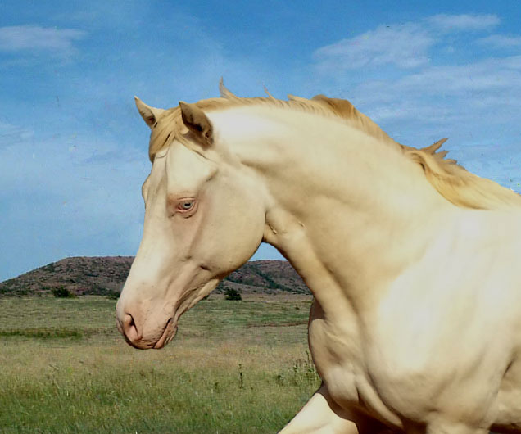 | Chasin My Dreams  AQHA  Also listed with APHA | 2012 Perlino  EeAACrCr  He sires 100% Palominos & Buckskins on Red or Bay mares. | $900  LCFG | He is a Grandson of  Frenchmans Guy  & Alive N Firen  (by Fire Water Flit)
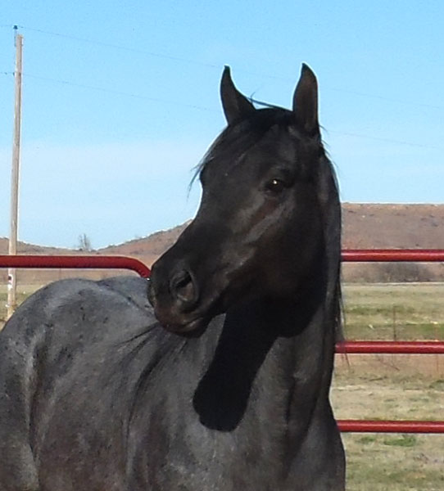 | Dash For Cash N Blue  AQHA | 2012 Blue Roan  15.1  EeaaRNrn | $1100  LFG  See note> | He is the Only true  Blue Roan Grandson of Dash For Cash in the world. Note- CALL to discuss him. I may have to wait before I can offer him to the public.
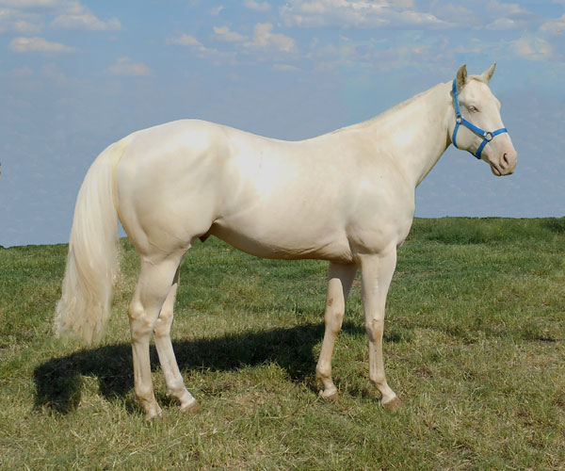 | Gold Fame N Fortune  AQHA  *also Listed with APHA | 2011 Cremello  16.0+, eeAACrCr | $1100  LCFG | Enrolled in  Future Fortunes Program. Grandson of Dash Ta Fame.
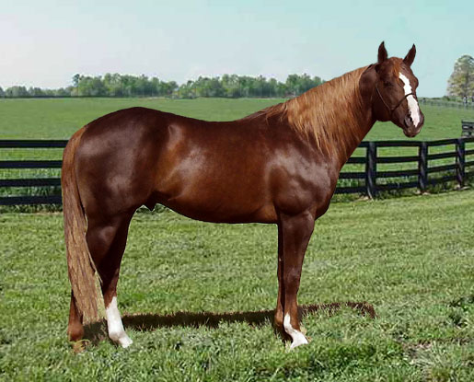 | Go To Moons  AQHA  *also listed with  AQHA, ApHC | 2002 Sorrel/Chestnut  15.3 eeAa | $750  LFG | Son of Marthas Six Moons,  Leading barrel sire
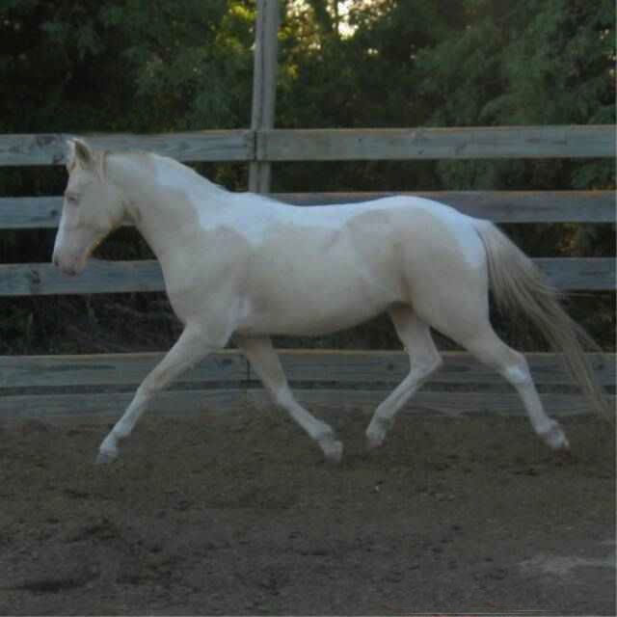 | KSC Ghost Dancer -Registered Pinto Pony | 2003 Cream Tobiano  Homozygous Cream and Tobiano. 47” tall  EeaaTTCRCR | $500  LCFG | Sires 100% Color!  Foals guaranteed to be Tobiano /Pinto…  and foals can be registered with Pinto.
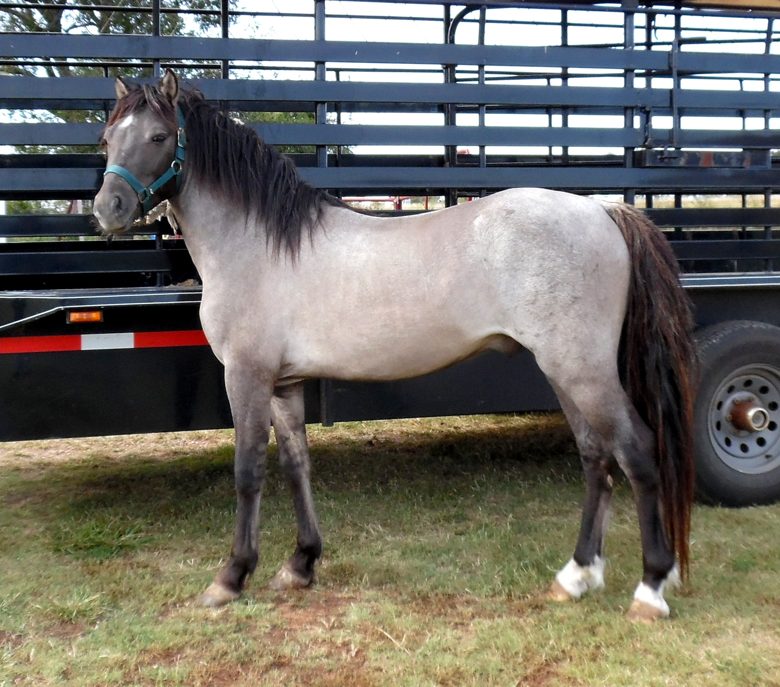 | KCS Time Traveler  WPCSA Sec. A  Purebred Welsh Pony | 2013  Grullo/Cream/Roan  EeaaDNdnCRcrRNrn | $500  Introductory Fee  LCFG | He has sired 100% color to date. Breeding comes with a Color Guarantee. Crossbred Foals eligible for Registration as Half-Welsh
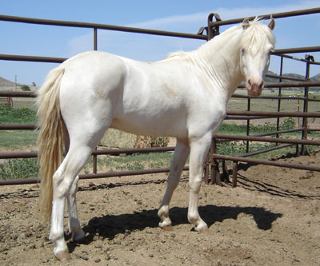 | KS Snowy River  ASPC Pony | 2006 Perlino Pony  45 inches  EeAACrCr | $500  LCFG | He sires 100% Color. We can accept Pony & Horse mares to this stallion.
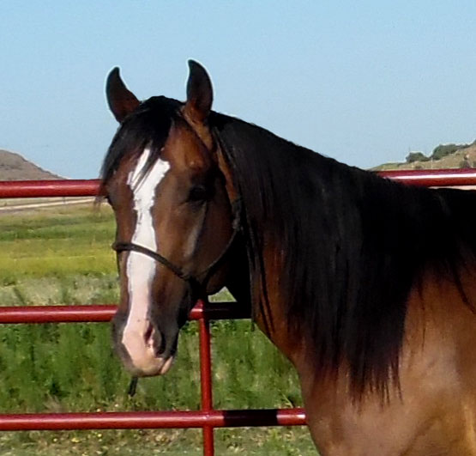 | Midnight Cool  AQHA | 2008 Bay  15.1  EeAa | $750  LFG | Son of Midnight Corona, by Mr Jess Perry.  Dam by Rocket Wrangler
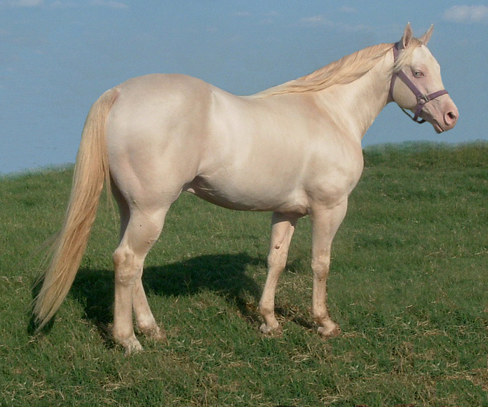 | Mr Poco Jessie Tivio  AQHA, APHA  (97% foundation)  *also listed with ApHC | 2001 Perlino  14.2  EEAACrCr | $900  LCFG | Sires 100% Buckskins on Red, Bay, Black, Dun mares.  25% Poco Bueno
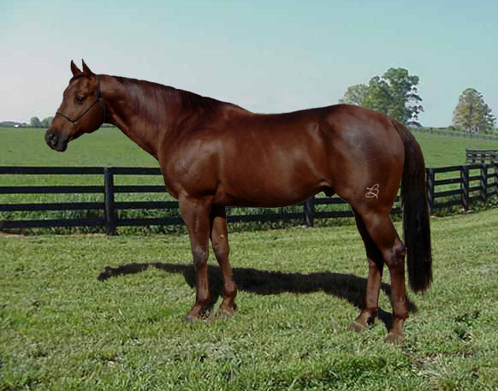 | Party Of Six  AQHA  *also listed with APHA | 1998 Sorrel/Chestnut  15.2 eeAA | $750  LFG | Son of Streakin Six,  Dam by Cash Legacy,  By Dash For Cash
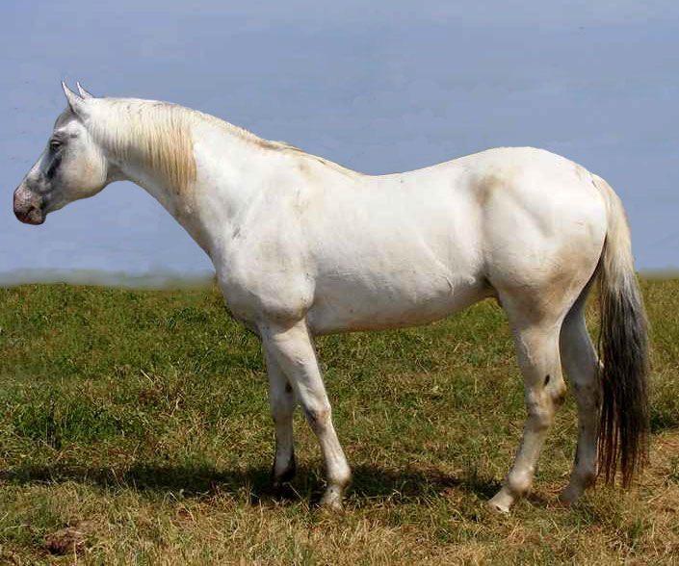 | Silverado Rein  ApHC | 2006 Black, Few Spot Appaloosa, 15.1, EEaaLPLP Homoz. Blk & App. | $750  LCFG | Sires 100% Appaloosa Spotted foals. All Breeds accepted. Colored Foal Guaranteed.
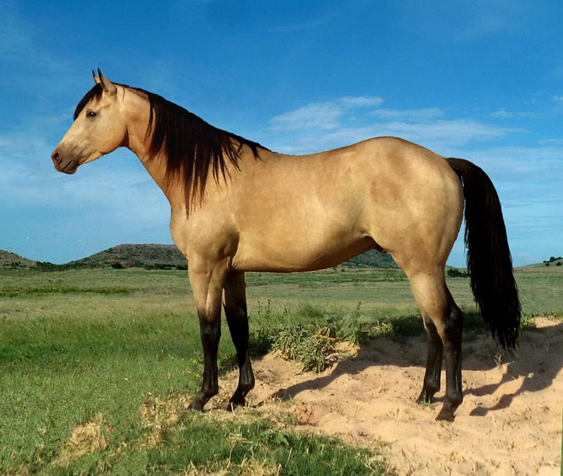 | Special French Bully  AQHA  also listed with APHA | 2012 Buckskin EEAACrcr  Homozygous Black. Sires Buckskins or Bays/Brns on all Sorrel mares. | $1100  LCFG | Son of Bully Bullion, and dam is by Frenchmans Guy.  Enrolled in Future Fortunes Program.
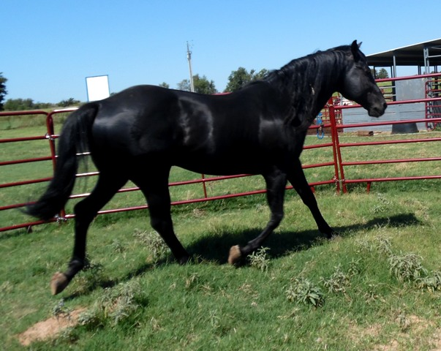 | The Shady Money  AQHA  *also Listed with APHA | 2000 Black 15.2  Eeaa (true black) | $750  LFG | Son of On The Money Red
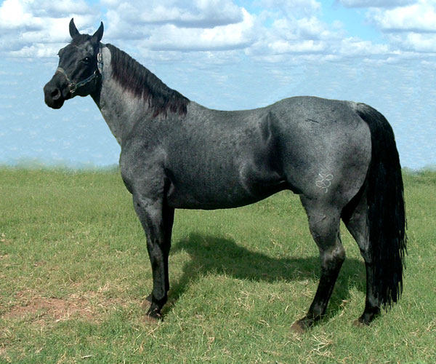 | Zach Blue  AQHA, FQHR  (98% Foundation)  *also listed with APHA | 1988 Blue Roan  EEaaRnRn  Hmz- Roan & Blk | $1000  LCFG | Limited Book / he is now semi-retired.  On-Farm A.I. only

These two stallions are for sale, but If I still have them during breeding season… I may offer them for breeding.
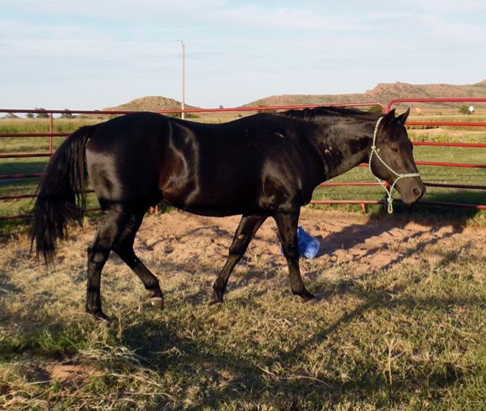 | Bandit Dun Bar  AQHA | Black  Homozygous for Black  EEaa | Currently For Sale.  Will stand at stud in future if not sold | Continental King and Foundation/Cutting bred
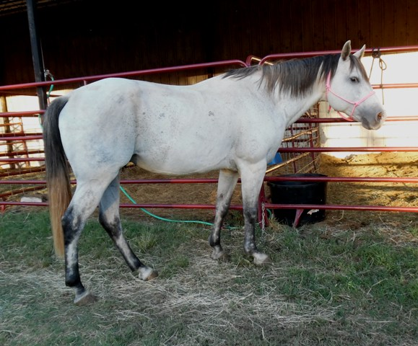 | Dontcha Skip King  AQHA  “Dusty” | Gray  EeAaGRgr | Currently For Sale.  Will stand at stud in future if not sold | Continental King and Foundation/Cutting/and Speed bred
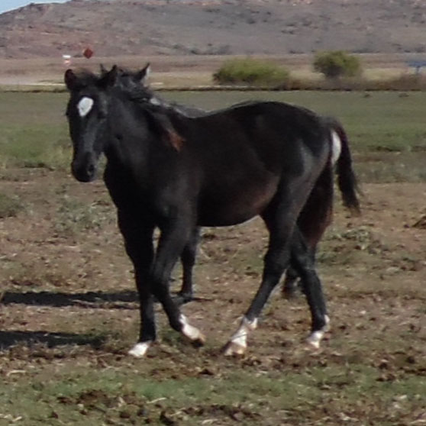 | Alotta Easy Money  “Tuxedo”  AQHA | 2015 Black  EEaa  Homozygous Black | Currently For Sale.  Will stand at stud in future if not sold | Grandson of On The Money Red, with Easy Jet, First Down Dash, etc in bloodline. Speed bred top and bottom.
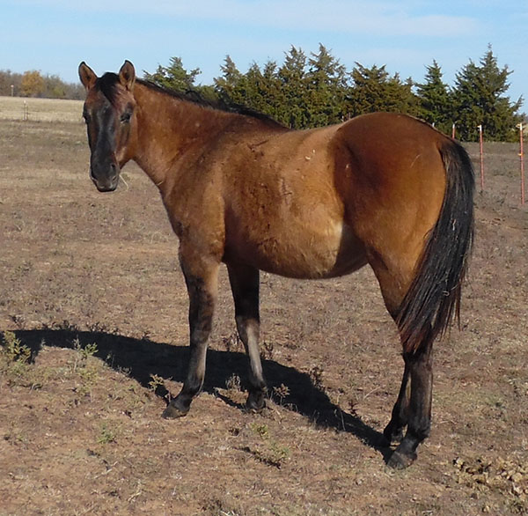 | Travelin Peponita  AQHA | 2015 Dun  EEAaDNdn  Homozygous Black | Currently For Sale.  Will stand at stud in future if not sold | Foundation and performance bred

* ** The Following stallions will be standing their First year at stud in 2017 or 2018.
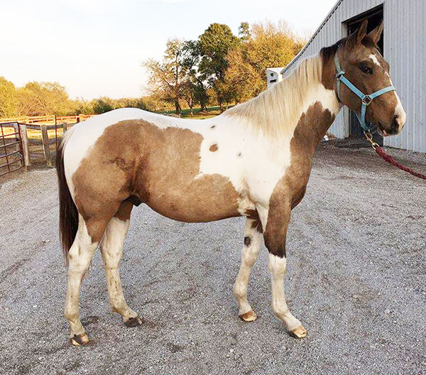 | Firewaters Image  APHA  “Jackpot” | 2015 Buckskin Tobiano  Homozygous for Tobiano & Black  EEA_TTCRcr | TBA | By son of  Fire Water Flit.  Dam by Champion race:  Cherokees Image
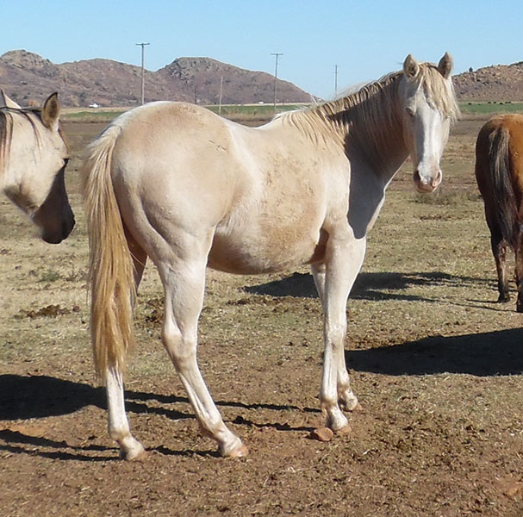 | FC Oklahoma Wildfire  “Wildfire”  AQHA | 2015 Perlino  Homozygous for Cream  EeAaCRCR | TBA | By son of  Fire Water Flit.  dam by Rare Bar.  2nd dam by Oklahoma Fuel
 | Show Me The Magic  Welsh Cross Pony | 2014 Perlino  Homozygous for Cream  EeAaCRCR | $500 | Guaranteed a Colored Foal!
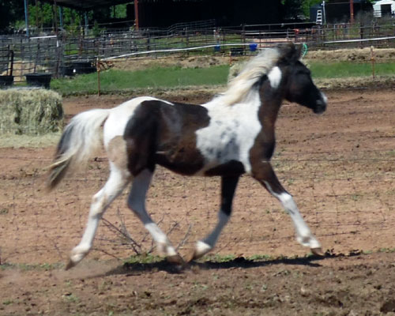 | KCS Ghost Buster  Reg, Pinto Pony | 2015 Smokey Black Tobiano  Homozygous Tobiano  EeaaTTCRcr | $500 | Guaranteed Pinto Foal!
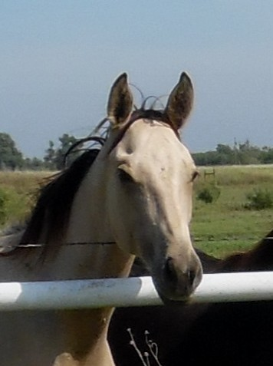 | Driftin Wood Buck  AQHA  “Drifter” | 2015 Buckskin Dun  EeAaDNdnCRcr | TBA | High % Driftwood
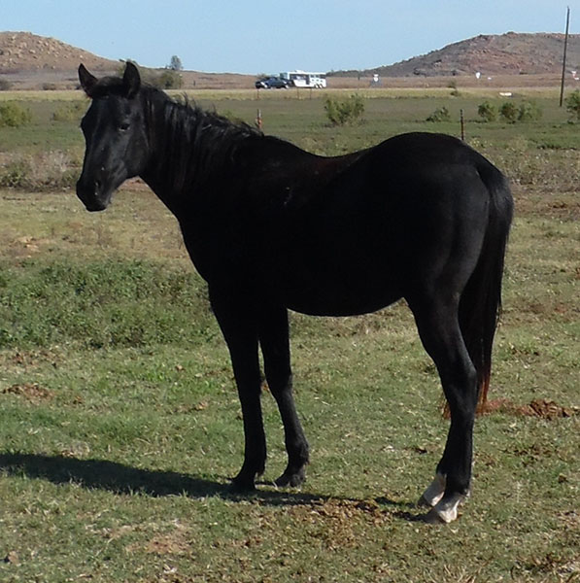 | “Charlie”  Speedy Lil Cowboy  AQHA | 2015 Black  EEaa  Homozygous Black | TBA | 13.48% Driftwood
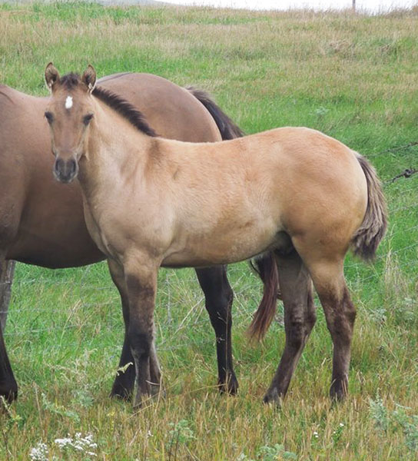 | “Nemo”  AQHA | 2016 Dun  EEAaDNDN  Homozygous for Black  & Homozygous for Dun | TBA | Foundation and Performance bred.  He will sire 100%  Black Pointed Duns  and Grullos!

Contact- Bedonna Dismore- 580-471-4040
Website- www.bedonna.com

